WALL STREET CLUB
BITS PILANI

FLOWUS
EXECUTIVE COMMITTEE 2019 - 2020

MODULE 2:
MOMENTUM TRADING

MOMENTUM

INTRODUCTION
Momentum style traders believe that these trends will continue to head in the same direction because of the momentum that is already behind them. On paper, momentum investing seems less like an investing strategy and more like a knee-jerk reaction to market information. The idea of selling losers and buying winners is seductive, but it flies in the face of the tried and true Wall Street adage, "buy low, sell high". Momentum investing seeks to take advantage of market volatility by taking short-term positions in stocks going up and selling them as soon as they show signs of going down, then moving the capital to a new position. In this case, the market volatility is like waves in the ocean, and a momentum investor is sailing up the crest of one, only to jump to the next wave before the first crashes down again.
Trading momentum markets require sophisticated risk management rules to address volatility, overcrowding, and hidden traps that reduce profits. Market players routinely ignore these rules, blinded by an overwhelming fear they will miss the rally or sell off while everyone else books windfall profits.
The risk side of the equation must be addressed in detail, or the momentum strategy will fail. The pitfalls of momentum trading include:
- Jumping into a position too soon, before a momentum move is confirmed.
- Closing the position too late, after saturation has been reached.
- Failing to keep eyes on the screen, missing changing trends, reversals or signs of news that take the market by surprise.
- Failing to act quickly to close a bad position, thereby riding the momentum train the wrong way down the tracks.

Momentum investing works best in a bull market because investors tend to herd a lot more. In a bear market, the margin for profit on momentum investing shrinks in accordance with increased investor caution.
This module aims to provide knowledge about tools and techniques to understand the basics of momentum trading and make one capable of taking trades based on momentum strategies. The following important momentum indicators will be covered in this module:
- Moving Averages
- Relative Strength Index (RSI)
- Moving Average Convergence Divergence (MACD)
- Average Directional Index (ADX)
- Volume
- Volatility Index (VIX)
MOVING AVERAGES
Moving average is the simplest and the most powerful tool in technical analysis. As the name suggests the tools calculates the average of the past n periods. They are dynamic trend lines on chart and hence are non-linear in nature. It helps smooth out the price action and remove the noise, which comes due to short-term fluctuations in the market. Its purpose is to signal if a new trend has begun or an old trend has ended or reversed. The general understanding is that when the stock prices are above the moving average, the stock is considered to be bullish and vice versa. The average can be calculated based on open, close, high low, etc. but we will stick to the standard of using the close price to calculate the moving average. There are many types of moving averages like simple, exponential, weighted, triangular etc. but we will focus only on one, the simple moving average.
Simple Moving Average
This is how simple it can get. To calculate Simple Moving Average (SMA), you take the arithmetic mean of the past n periods. Simple however, this tool is very powerful and can speak a lot about the markets/instrument. This tool is used by many trading houses to determine trades and take position in the market. The crossing above a moving average is taken to be a buy signal and crossing below is taken to be a sell signal. Many traders prefer that the direction of the moving average be also along the price direction before entering into a trade. However, the period of the moving average is important as if the period is too long, the signal will be generated too late and if the period is short, there can be false signals.
The most important and frequently used SMA are:
- 200 Daily Moving Average (Long Term).
- 100 Daily Moving Average (Medium term).
- 50 Daily Moving Average (Short term).
I would like to establish a rule of thumb, if the stock is trading below the 200 Daily Moving Average (DMA), you do not trade that stock.
The 200 DMA is used to determine the long-term trend of the stock. If you are using fundamental analysis to invest in a company, you should check whether the stock is trading above 200 DMA or not if you want to take a position.
The 100 DMA is used to determine the intermediate trend. If you are planning to put you money in the market for 1-2 months, 100 DMA should be below the current stock price.
The 50 DMA is used to determine the short-term trend. The price should be above 50 DMA while taking positional trades.

As mentioned that the moving averages are dynamic trend lines, they act like one. When price comes nears a moving average, the moving average acts as a support or a resistance. The most commonly used SMA is the 20 DMA as the range is perfect for giving an entry/exit position in the market. Other commonly used moving averages are of the Fibonacci series: 8, 13, 21, 34, etc.
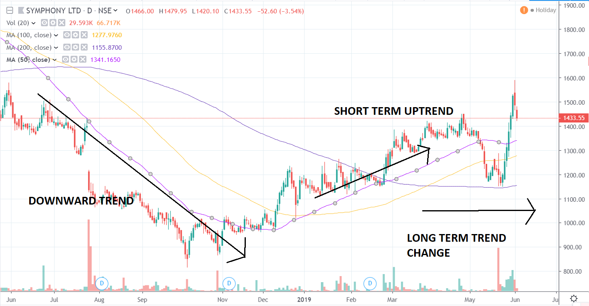
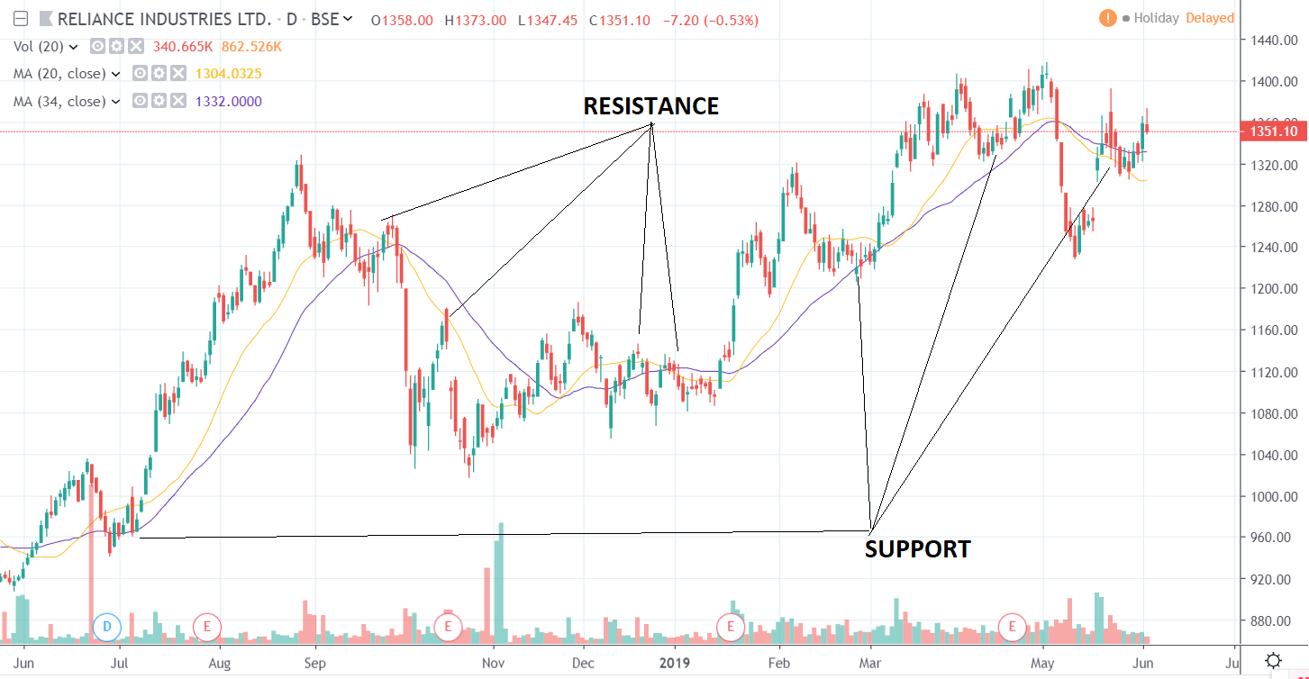
Trading using moving averages
As you might have guessed, you cannot use only one moving average to trade, there are systems developed using multiple moving averages to take positions in the market. Generally, you take a combination of two moving averages of Fibonacci period. However, one can try out other combinations and use strategies suitable to their liking. One can further expand and use three or more moving averages to take trades but the complexity in doing such increases exponentially and is better left unknown. I will show you one trading strategy using the 13 SMA and 34 SMA. One should always keep in mind that not every trade you take would be successful. There will be ups and downs and if you are having a success ratio of 0.7 you are already beating the market!

The Double Crossover
The strategy uses 2 moving average to generate buy and sell signals. If the smaller of the moving average crosses above the larger one you take a long position. Every time the price hits the smaller moving average, you increase your exposure, called pyramiding by adding around 10% of your initial investment (but is not necessary to carry out). Once the smaller moving average comes below the larger one you square off your position or you can exit if some target percentage has been achieved. Whenever trading, one should always keep stop loss in your position. The stop loss can be some resistance, support or some moving average. If the stop loss moves along with time, it is called trailing stop loss.
Let look at it applied in some stocks.
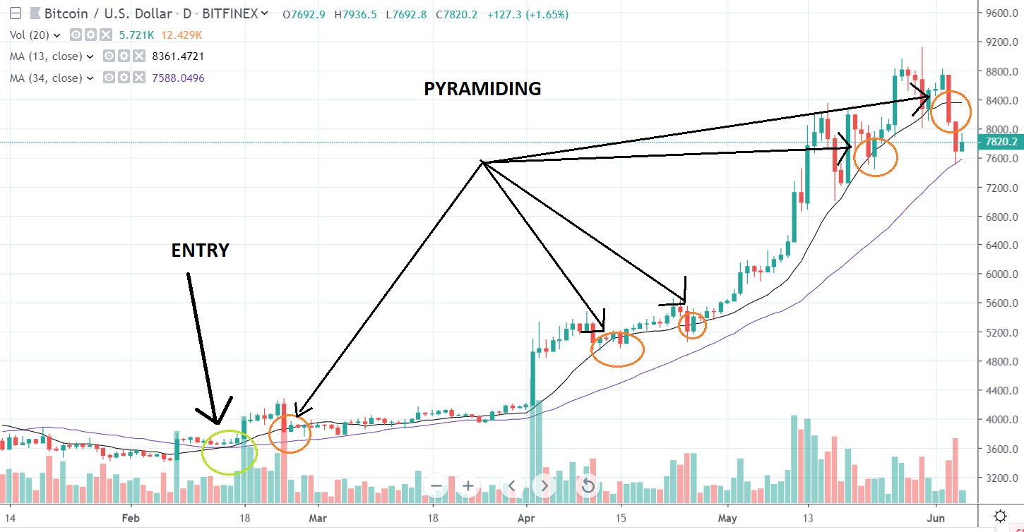
As you can see, according to the strategy we would have entered around 15 February with a stop loss around 3500 and would have increased our exposure near 15 March, 24 April, etc.
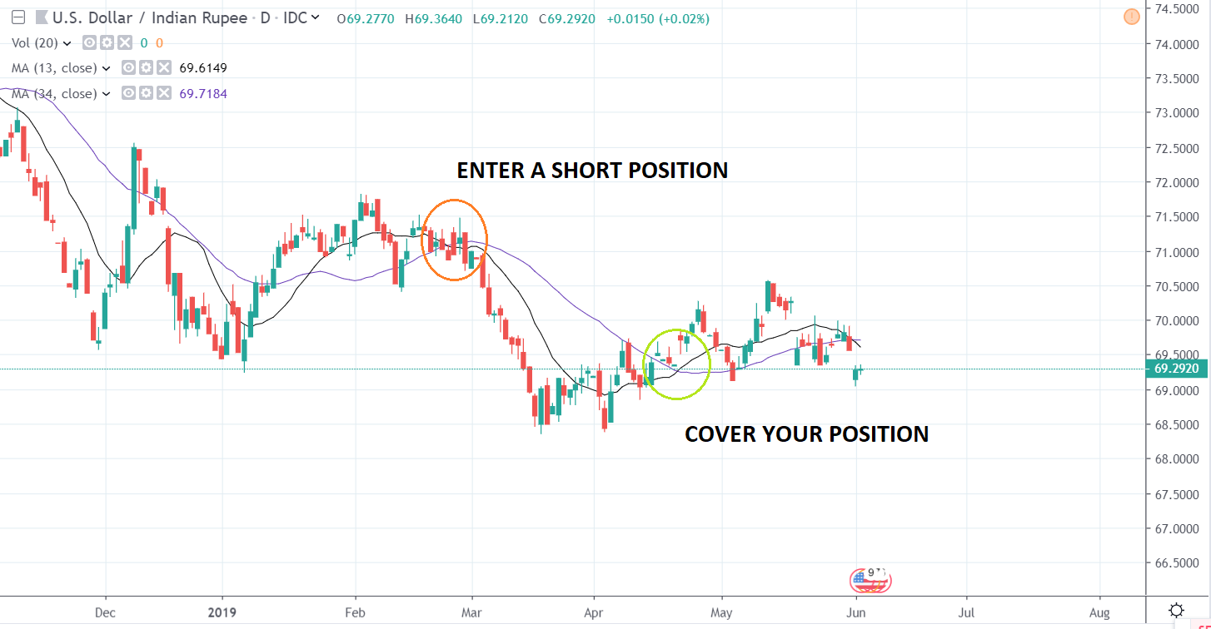
In the above figure, you can see that in the first trade you would have made a decent profit by taking a short position in February and covering up in April. However, if you were to jump immediately into a long position after exiting the trade, you would have made losses. To avoid this let us laydown one rule while using moving averages: you trade stocks, which are trending or have consolidated in the recent history. In the sideways market, it is better to avoid using moving averages as there will be many whipsaws and you are bound to get many false signals. Also, never take position opposite to your trade just after exiting the trade. You are bound to lose money.
Another beautiful example:
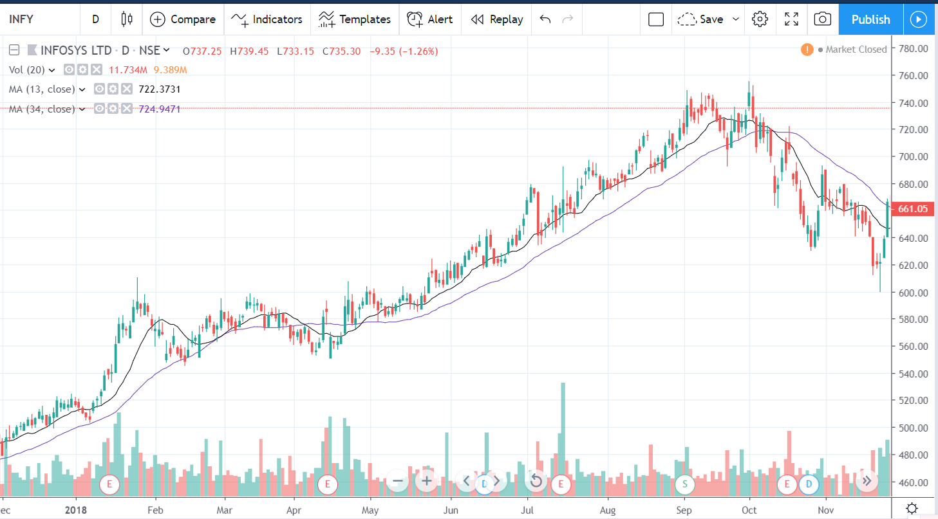
The above system works fine when used alone but to get better results it is better to combine this with another tool called the Relative Strength Index (RSI).

RELATIVE STRENGTH INDEX
The relative strength index (RSI) is a momentum indicator that measures the magnitude of recent price changes to evaluate overbought or oversold conditions in the price of a stock or other asset. The RSI is displayed as an oscillator (a line graph that moves between two extremes) and can have a reading from 0 to 100. J. Welles Wilder Jr. originally developed the indicator. Moving averages can tell someone if the price is going up or down but RSI tells you how fast the price is moving. It can be related to velocity of a moving object.
As Wilder pointed out the problem with moving averages is the erratic movement caused by drop of some large value 14 days ago (for a 14 period moving average) can cause sudden changes in the line. Some smoothing is therefore necessary. He also points out that some constant range is necessary for comparison of two points at different time so a bounded oscillator will be required.
RSI can be calculated as follows:
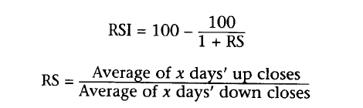
Here we can see that if the RS value is more, the value of RSI is more, it indicates a bullish phase of the market and if the value of RS is less, the value of RSI is less, and it indicates a bearish phase. Wilder used x value as 14 and that is still the most popular value. The shorter the period, the more sensitive the oscillator becomes and more fluctuations in the index.
One common misconception is that if the RSI value is more than 70, the script is in overbought region and if the RSI is below 30, the script will be in oversold region and it would be a good time to exit. It actually depends on the overall trend of the markets. If the markets in general are in an uptrend you should consider 80 as the overbought value and 30 as the oversold value and if the markets are in a down trend, consider 20 to be oversold value and above 70 to be overbought region.
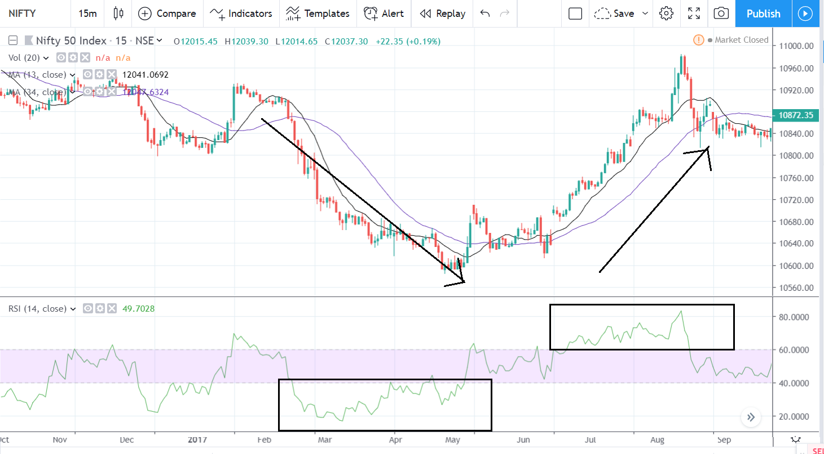
I would like to list one simple yet powerful strategy involving RSI and moving averages, which can be used for investment purposes.
In the weekly chart, when the RSI 14 goes above 60, invest in that scrip. When the price goes below 20 SMA exit your position. The instances when the RSI goes below 60 can be used for pyramiding.
Example:
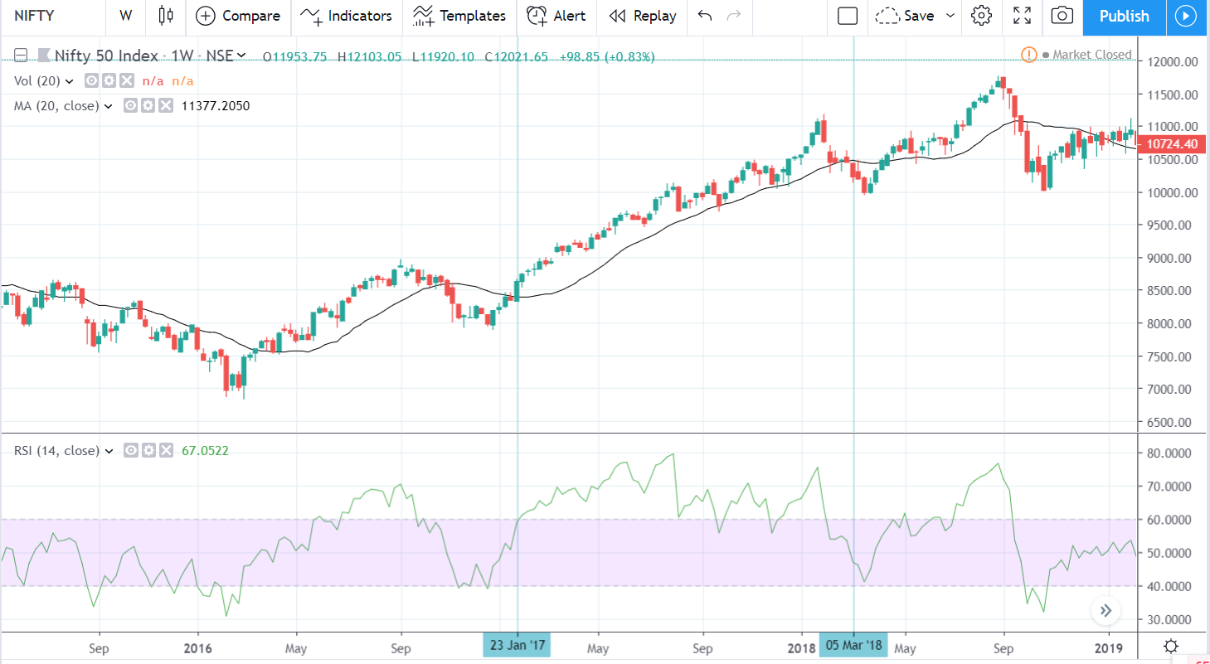

Next, I would like to list a strategy, which I would like to use in our meets.
Take any 3 time frames which are at least 4 times the size than the next one. For example daily, weekly, monthly or daily, hourly, 15 minutes. Select the stocks where the RSI in the two higher time frames is above 60 and has crossed 50 in the smallest one. The stock is most likely to go up and you should be able to follow a decent move in the price. Exit when you get 3-4 percent profit or the 8 exponential moving average goes below 21 exponential moving average.
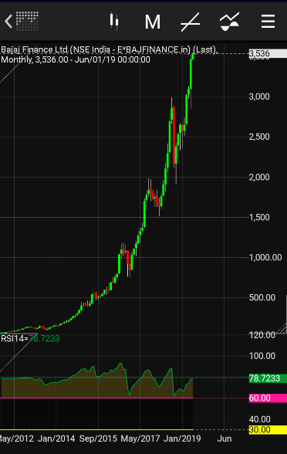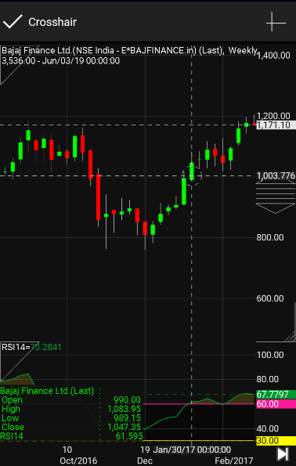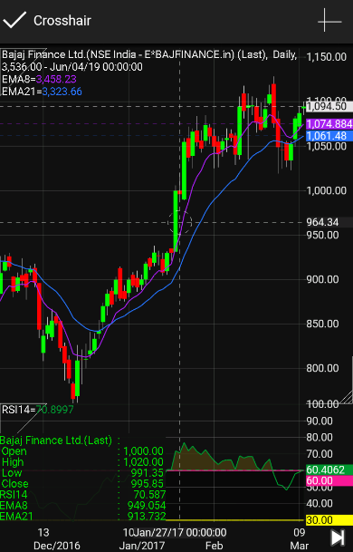

RSI DIVERGENCE
I hope you all are familiar with the term divergence. When two things are set to go away from each other, they are diverging. Similarly, when the direction of price and RSI is different, RSI divergence takes place. To identify divergence, we must try to look if the price is making higher highs and RSI is making lower highs and if price is making lower lows and RSI is making higher lows. However, this should not be used individually as there is common misconception that when this happens, the stock will see a trend reversal or the trend will stop and the stock will go sideways. Usually in one instance of divergence the stock sees some retracement and retracement calculating tools like Fibonacci retracements can be used to determine the retracement levels and short swing trades can be done.
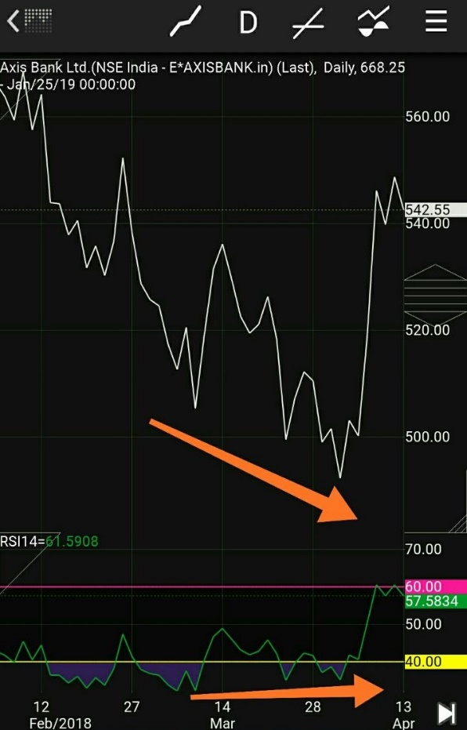
Here you can see that the RSI was making higher lows and the price in spite of making lower lows continued to go downwards. The skill lies in identifying which is a true divergence and will the stock reverse back or not. When RSI divergence takes place above 70 and below 30, it is more likely to be a retracement divergence and not a reversal divergence. Look at the early stages in the above image once again. In such markets, there will be false claims that the market is overbought/oversold and one should exit the position. The markets can stay in the overbought/oversold regions for some time and such claims can lead to missed moves.
Below are 2 examples of reversal divergence. Also in the first image, in the later stages, the divergence was above 30 so it was a reversal divergence.

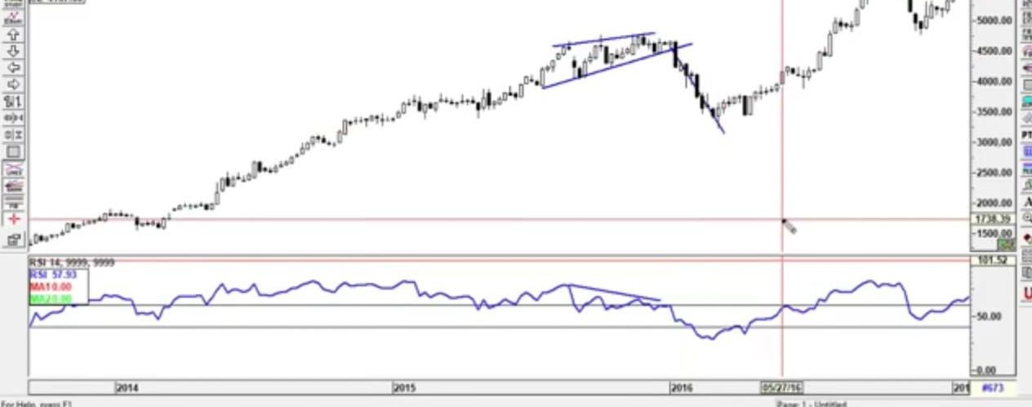
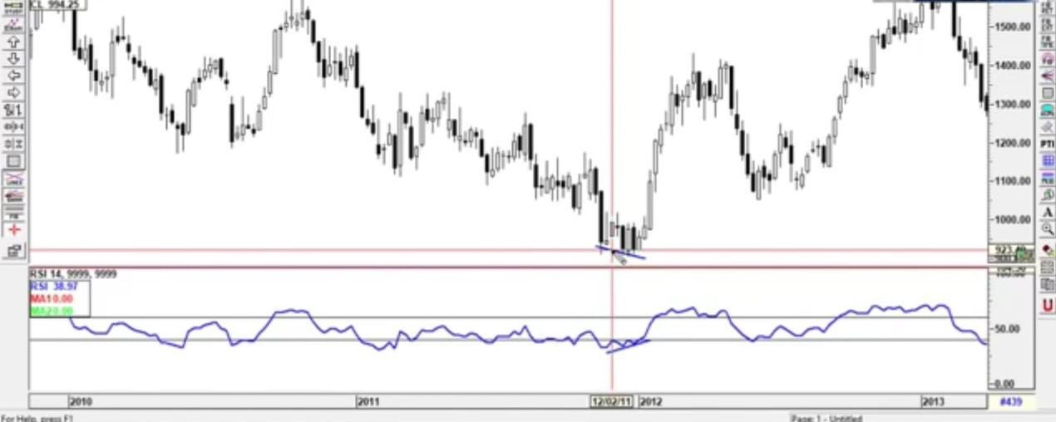

Sometimes RSI alone can be used to get into trades. If weekly RSI crosses the value 69 sharply, you can expect a good move coming in short time. Similarly if the monthly RSI is above 69, the stock will continue to rise and one should be long or increase their exposure.

MOVING AVERAGE CONVERGENCE DIVERGENCE
Moving average convergence divergence (MACD), combines oscillating principle with dual moving average crossover. The MACD is calculated by subtracting the 26-period Exponential Moving Average (EMA) from the 12-period EMA. The result of that calculation is the MACD line. A nine-day EMA of the MACD, called the "signal line," is then plotted on top of the MACD line, which can function as a trigger for buy and sell signals.
The actual buy signal is when the MACD line crosses over the signal line and the buy signal is when it crosses back below. This is same as the dual crossover method but the value of lines can become negative, here the oscillating nature of the indicator comes in.
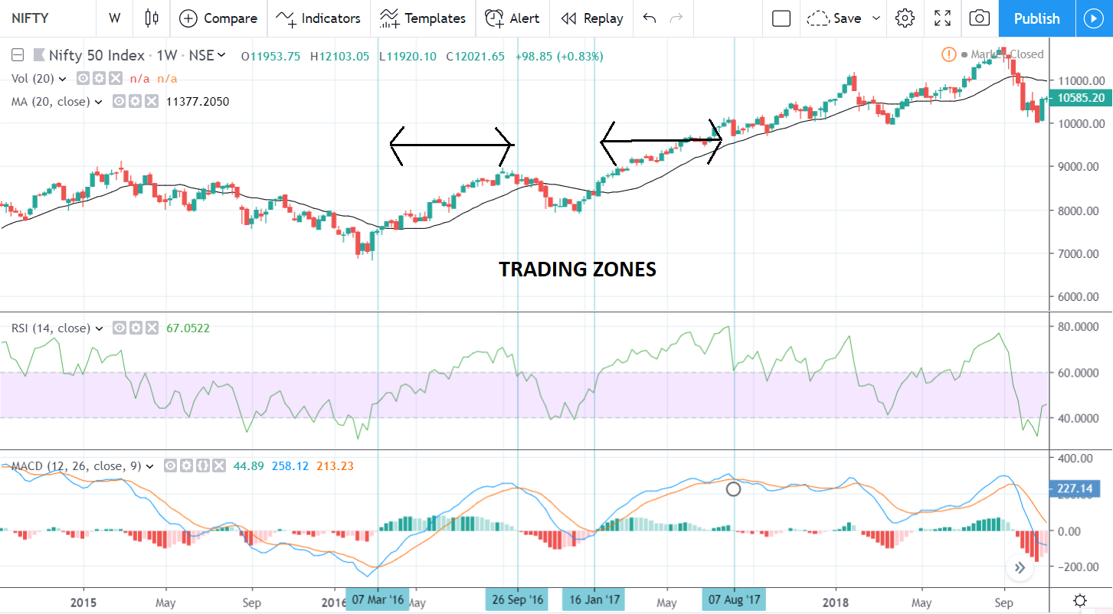
Divergence comes in when the trends of price and MACD lines are in opposite direction.

